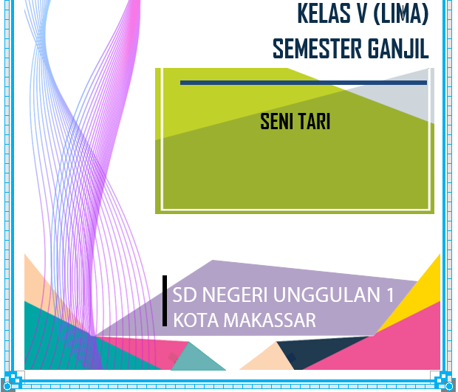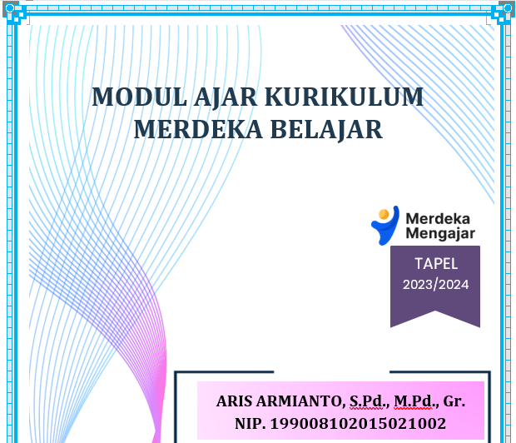

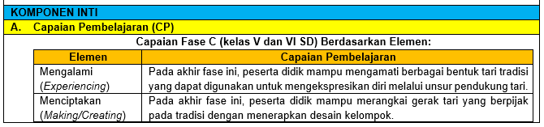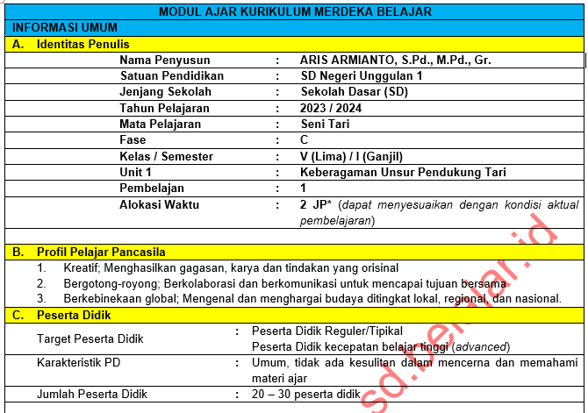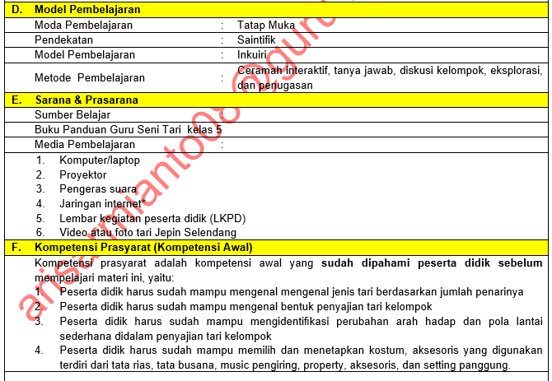

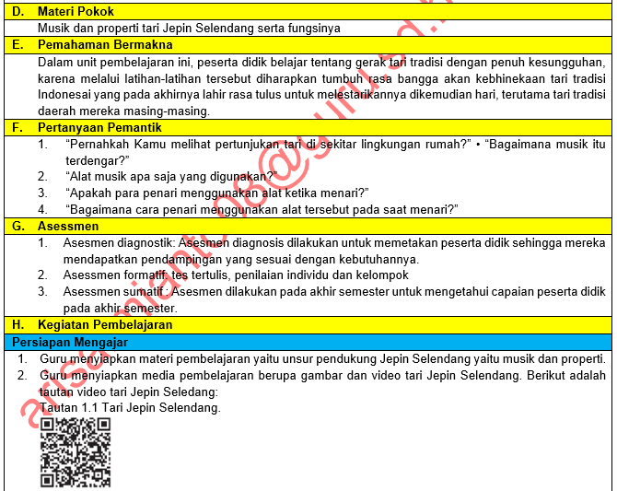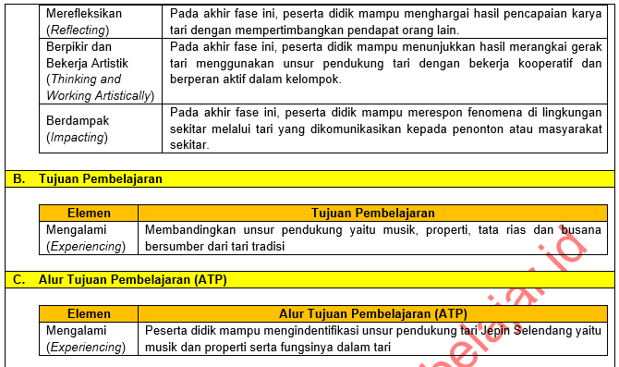

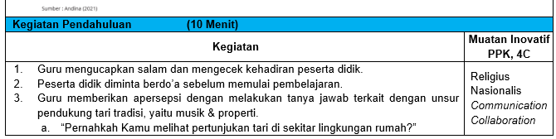

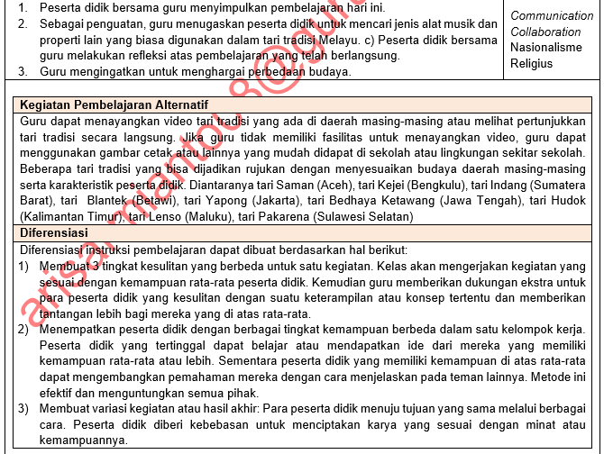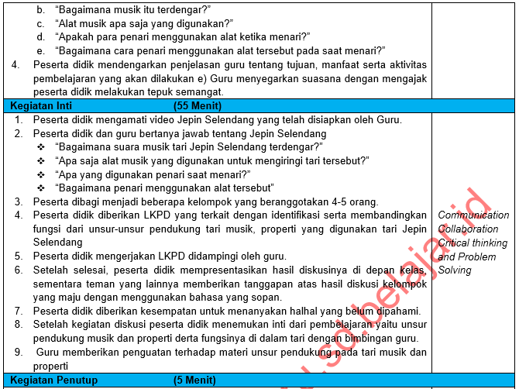

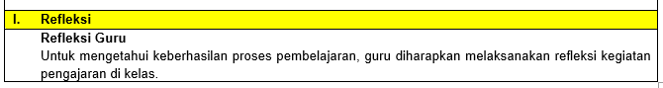

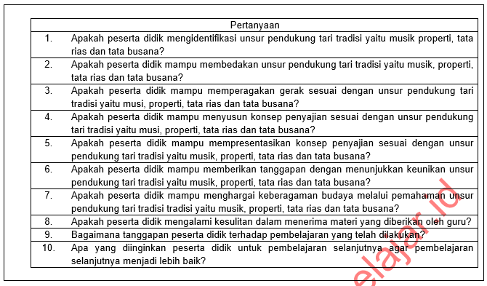

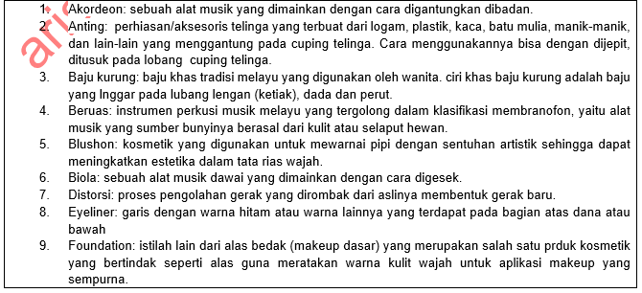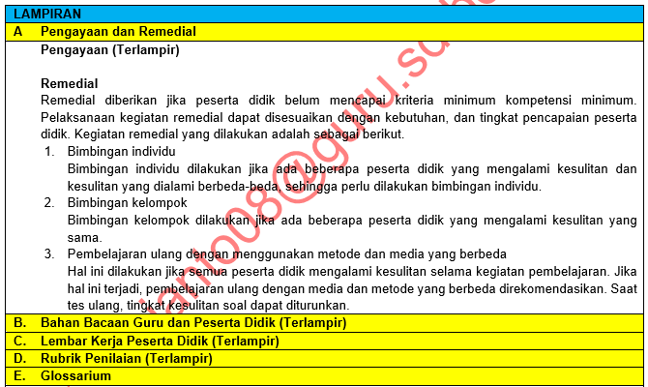

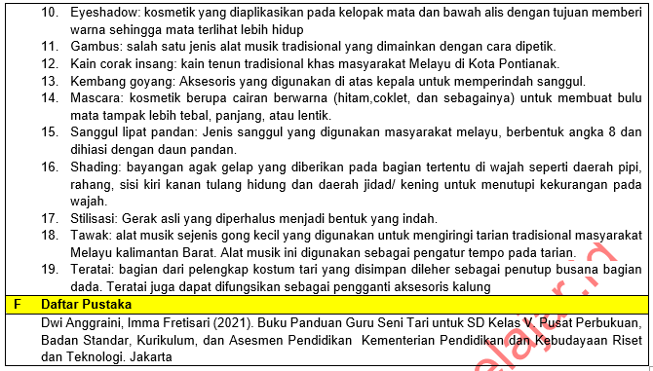

|  |  |
| --- | --- |
|  | Bulete, 2023 |
| Mengetahui: |  |
| Kepala SD Negeri Unggulan 1, | Guru kelas V, |
|  |  |
|  |  |
|  |  |
| **NADA NUR, S.Pd., M.Pd.** | **ARIS ARMIANTO, S.Pd., M.Pd., Gr.** |
| NIP. 197725122000012001 | NIP. 199008102015021002 |

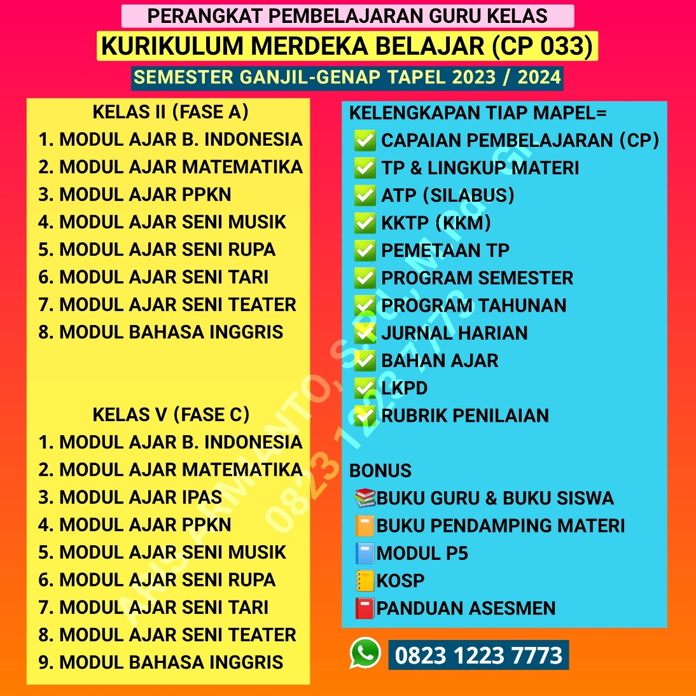

**MODUL AJAR KURIKULUM MERDEKA BELAJAR**

**CAPAIAN PEMBELAJARAN BERDASARKAN SK 033/H/KR/2022**

**KELAS V SEMESTER I (GANJIL) TAPEL 2023/2024**

**FILE LENGKAP SEMUA MATA PELAJARAN BESERTA ADMINISTRASI PENDUKUNGNYA DALAM BENTUK *WORD/DOC***

**FILE SAYA EDITKAN SESUAI DATA GURU**

**DALAM BENTUK *WORD/DOC* SIAP *PRINT OUT***

**WhatsApp : 0823 1223 7773**

**CP - ATP DAN KELENGKAPANNYA PADA HALAMAN TERAKHIR MODUL INI**

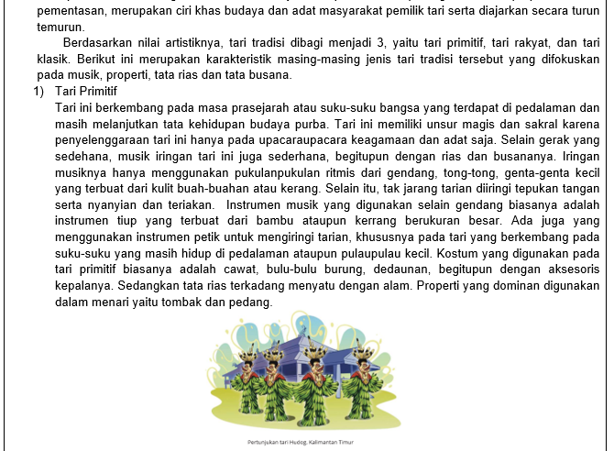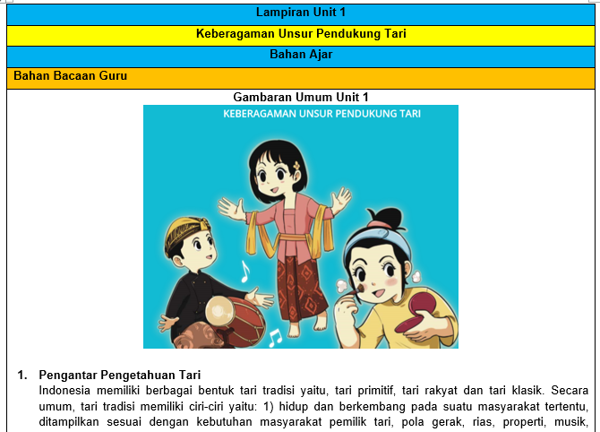

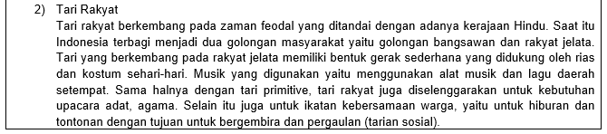

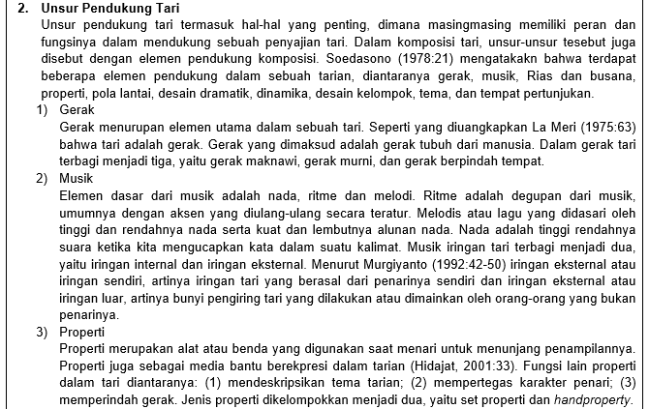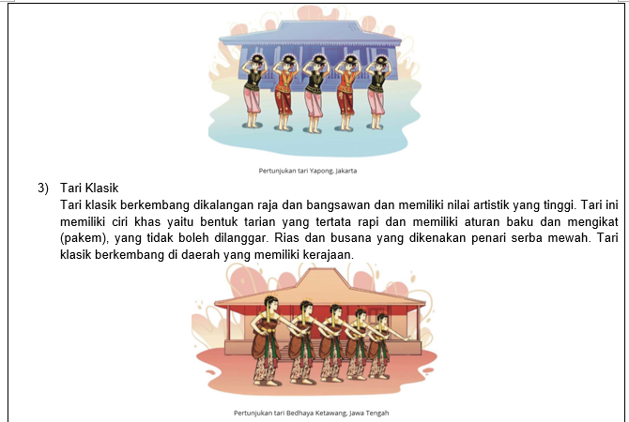

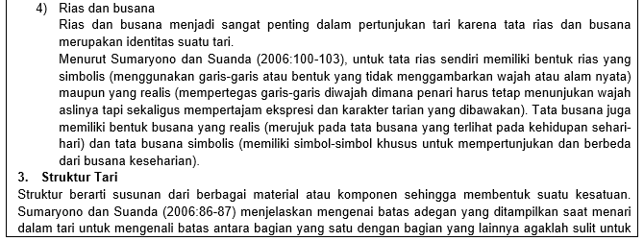



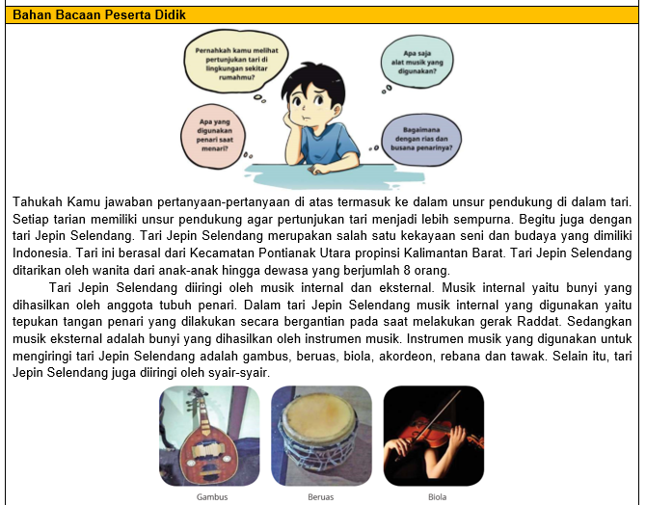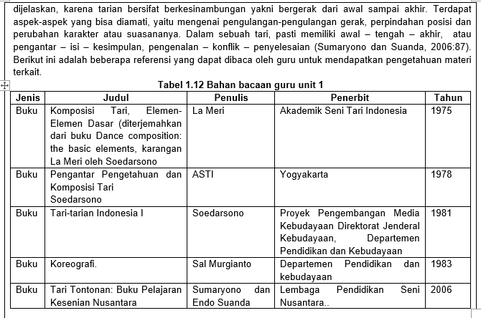



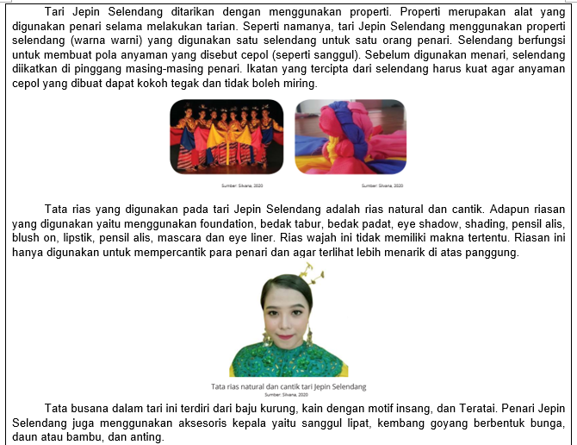

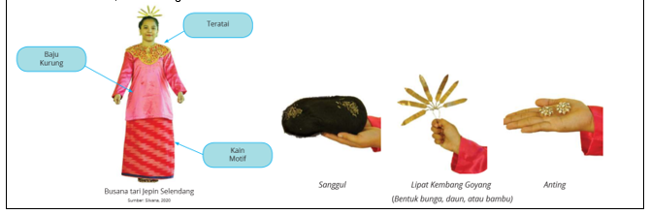

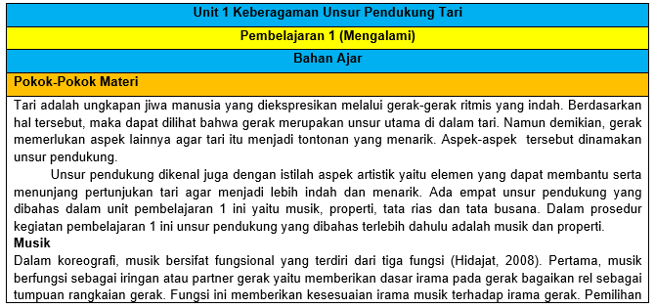

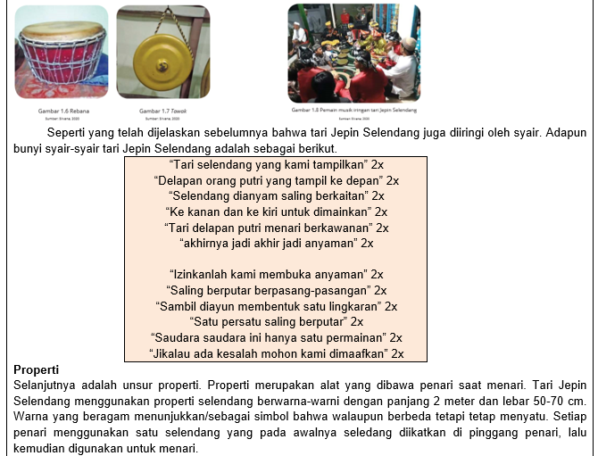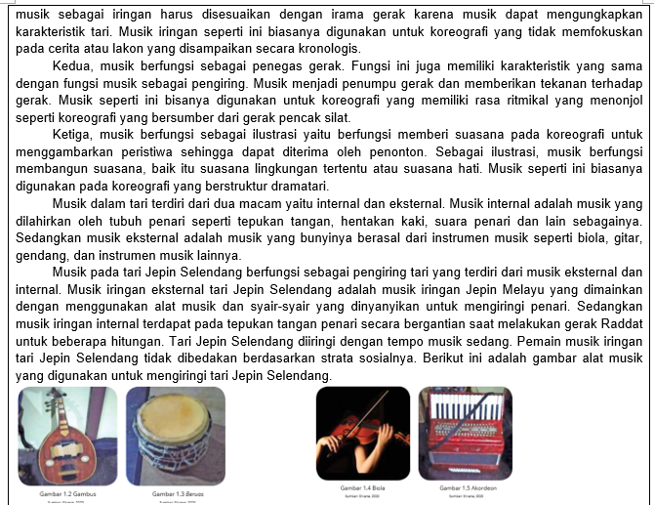



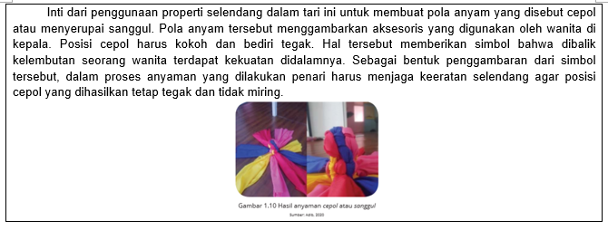

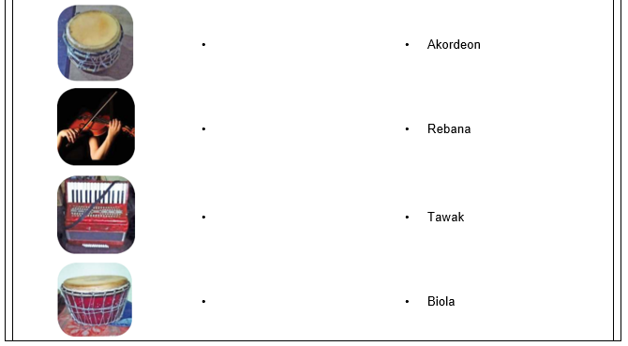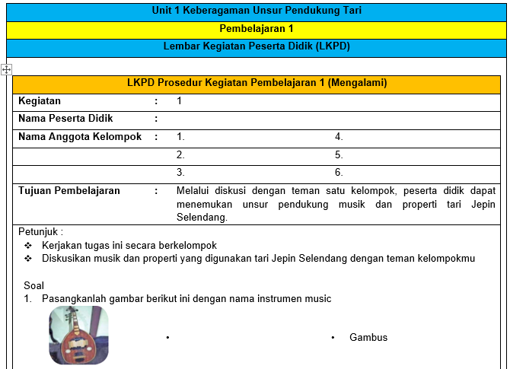

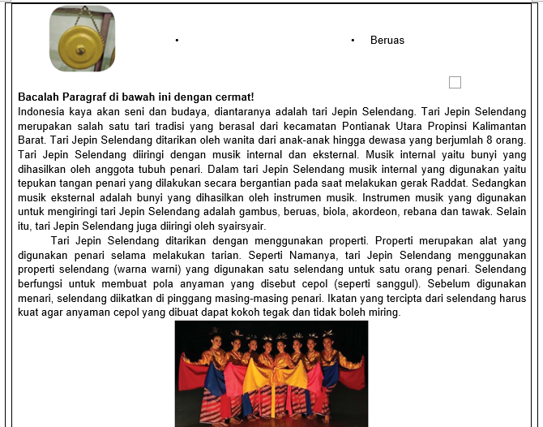

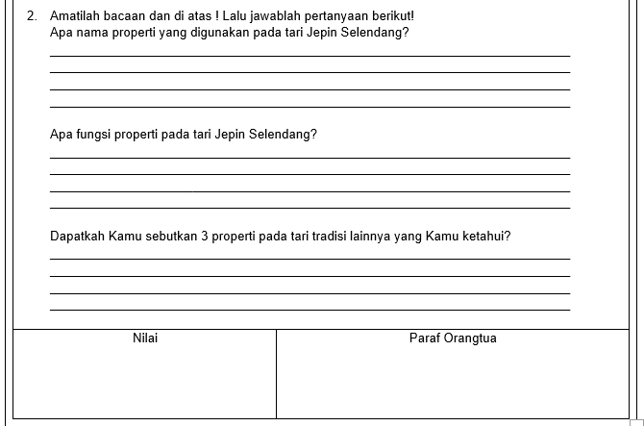

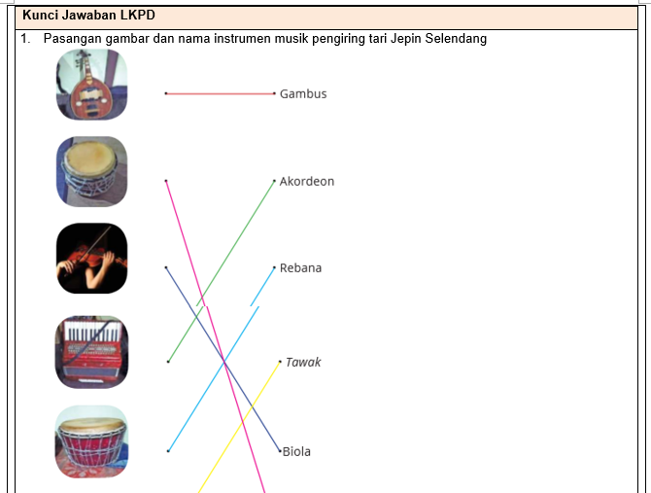

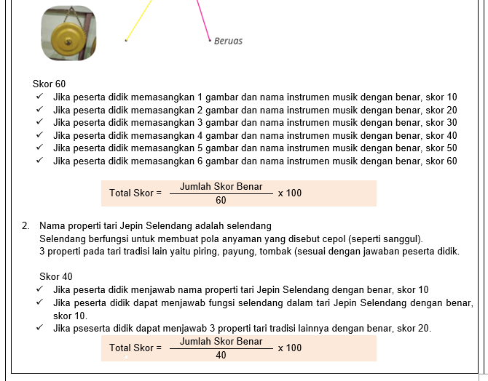

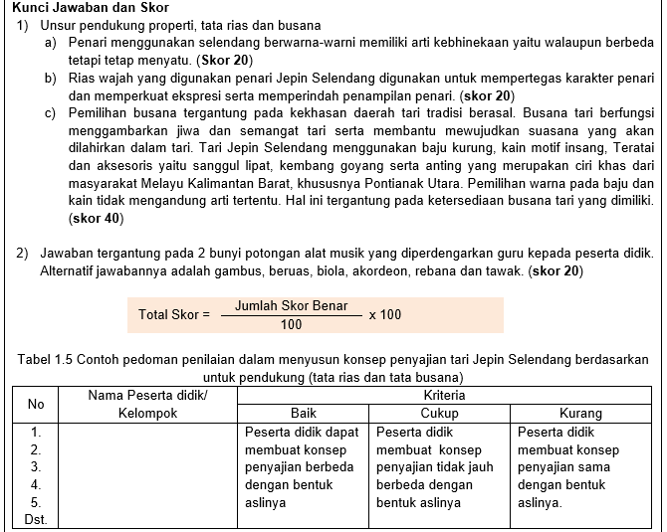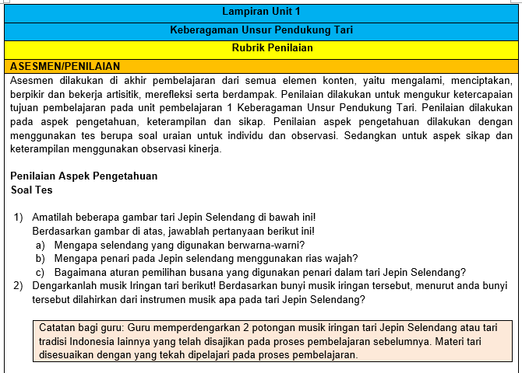

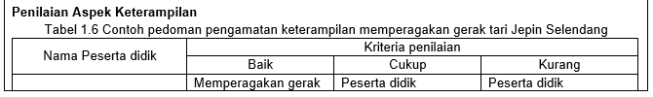

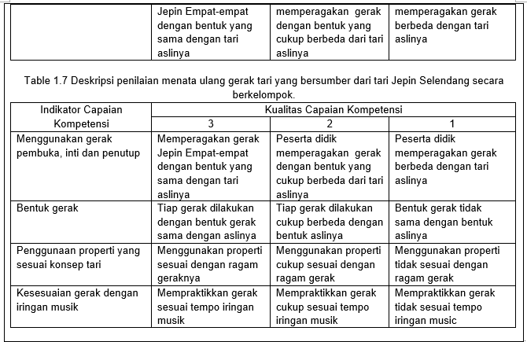

**MODUL AJAR KURIKULUM MERDEKA BELAJAR**

**CAPAIAN PEMBELAJARAN BERDASARKAN SK 033/H/KR/2022**

**KELAS V SEMESTER I (GANJIL) TAPEL 2023/2024**

**FILE LENGKAP SEMUA MATA PELAJARAN BESERTA ADMINISTRASI PENDUKUNGNYA DALAM BENTUK *WORD/DOC***

**FILE SAYA EDITKAN SESUAI DATA GURU**

**DALAM BENTUK *WORD/DOC* SIAP *PRINT OUT***

**WhatsApp : 0823 1223 7773**

|  |  |  |
| --- | --- | --- |
| **CAPAIAN PEMBELAJARAN** | | |
| **Satuan Pendidikan** | **:** | **SD Negeri Unggulan 1** |
| **Kelas / Semester** | **:** | **V (Lima) / I (Ganjil)** |
| **Tahun Pelajaran** | **:** | **2023 / 2024** |

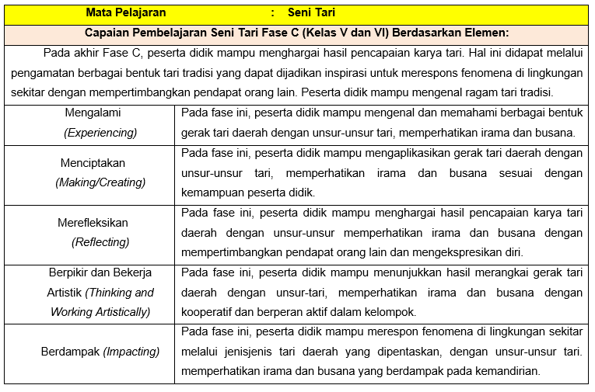

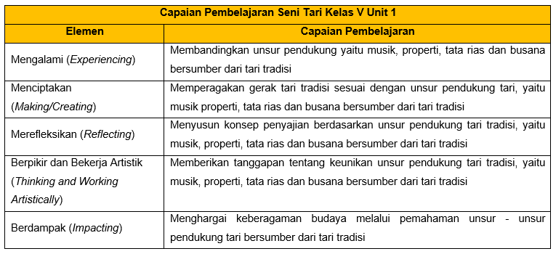

|  |  |  |
| --- | --- | --- |
| **ALUR TUJUAN PEMBELAJARAN (ATP) KURIKULUM MERDEKA BELAJAR** | | |
| **Nama Penyusun** | **:** | **ARIS ARMIANTO, S.Pd., M.Pd., Gr.** |
| **Satuan Pendidikan** | **:** | **SD Negeri Unggulan 1** |
| **Kelas / Semester** | **:** | **V (Lima) / I (Ganjil)** |
| **Tahun Pelajaran** | **:** | **2023 / 2024** |

|  |  |  |
| --- | --- | --- |
| **Mata Pelajaran** | **:** | **Seni Tari** |

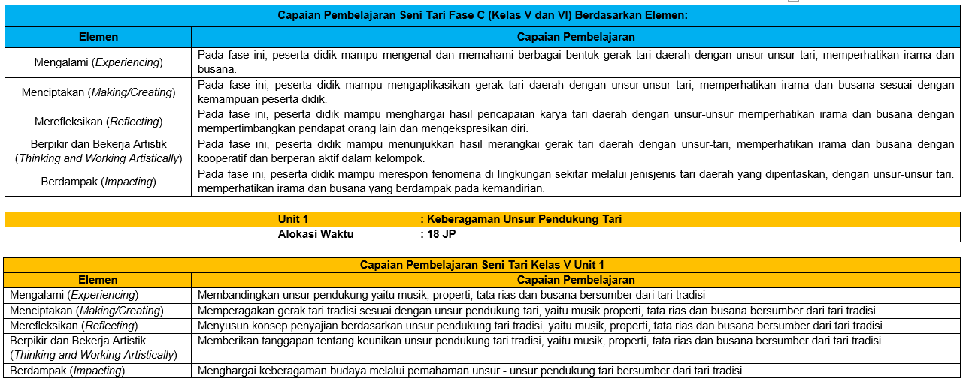

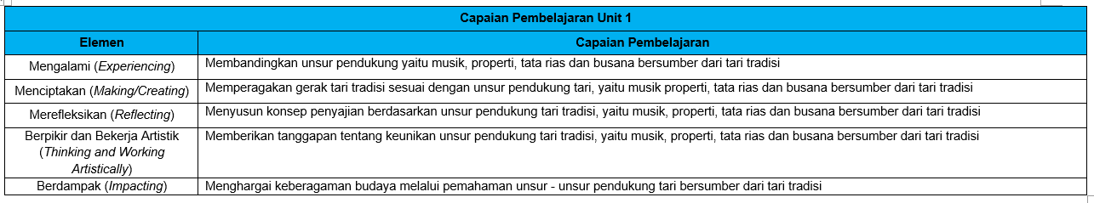

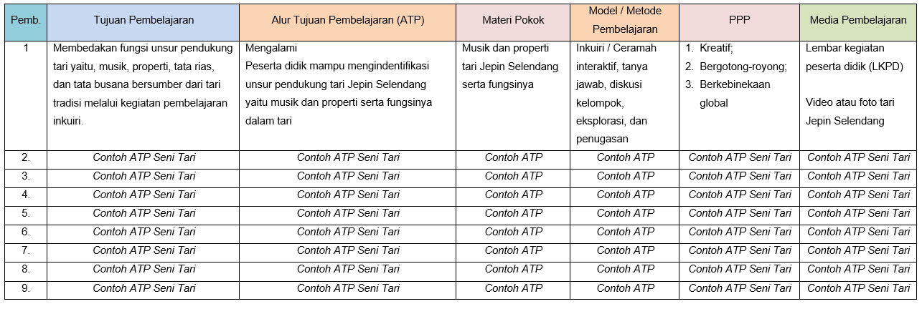



**MODUL AJAR KURIKULUM MERDEKA BELAJAR**

**CAPAIAN PEMBELAJARAN BERDASARKAN SK 033/H/KR/2022**

**KELAS V SEMESTER I (GANJIL) TAPEL 2023/2024**

**FILE LENGKAP SEMUA MATA PELAJARAN BESERTA ADMINISTRASI PENDUKUNGNYA DALAM BENTUK *WORD/DOC***

**FILE SAYA EDITKAN SESUAI DATA GURU**

**DALAM BENTUK *WORD/DOC* SIAP *PRINT OUT***

**WhatsApp : 0823 1223 7773**

|  |  |  |
| --- | --- | --- |
| **KRITERIA KETERCAPAIAN TUJUAN PEMBELAJARAN** | | |
| **Institusi** | **:** | **SD Negeri Unggulan 1** |
| **Kelas / Semester** | **:** | **V (Lima) / I (Ganjil)** |
| **Tahun Pelajaran** | **:** | **2023 / 2024** |

|  |  |  |  |  |  |  |
| --- | --- | --- | --- | --- | --- | --- |
| **Mata Pelajaran** | **:** | **Tari** | | | | |
| **Unit 1** | **:** | **Keberagaman Unsur Pendukung Tari** | | | | |
| **Tujuan Pembelajaran** | | | | | | |
| Membedakan fungsi unsur pendukung tari yaitu, musik, properti, tata rias, dan tata busana bersumber dari tari tradisi melalui kegiatan pembelajaran inkuiri. | | | | | | |
| **Kriteria Ketuntasan** | | | **Interval** | | | |
| 0 – 40% | 41 – 65% | 66 – 85% | 86 – 100% |
| Mengalami   1. Mampu mengindentifikasi unsur pendukung tari Jepin Selendang yaitu musik dan properti serta fungsinya dalam tari | | |  |  |  |  |
| 1. *Contohh KKTP* | | |  |  |  |  |
| 1. *Contohh KKTP* | | |  |  |  |  |
| 1. *Contohh KKTP* | | |  |  |  |  |
| 1. *Contohh KKTP* | | |  |  |  |  |
| 1. *Contohh KKTP* | | |  |  |  |  |
| 1. *Contohh KKTP* | | |  |  |  |  |
| 1. *Contohh KKTP* | | |  |  |  |  |
| 1. *Contohh KKTP* | | |  |  |  |  |
| 1. *Contohh KKTP* | | |  |  |  |  |
| 1. *Contohh KKTP* | | |  |  |  |  |
| 1. *Contohh KKTP* | | |  |  |  |  |
| 1. *Contohh KKTP* | | |  |  |  |  |

|  |  |  |
| --- | --- | --- |
| **Interval** | **Kriteria** | **Intervensi** |
| 0-40% | Belum Mencapai Tujuan | Remedial Di Seluruh Bagian |
| 41-65% | Belum Mencapai Tujuan | Remedial Di Bagian Yang Diperlukan |
| 66-85% | Sudah Mencapai Tujuan | Tidak Perlu Remedial |
| 86-100% | Sudah Mencapai Tujuan | Perlu Pengayaan Atau Tantangan Lebih |
| **Kesimpulan :**  Tuntas (mencapai TP) jika minimal 9 dari 13 kriteria berada pada interval nilai 66-85% | | |

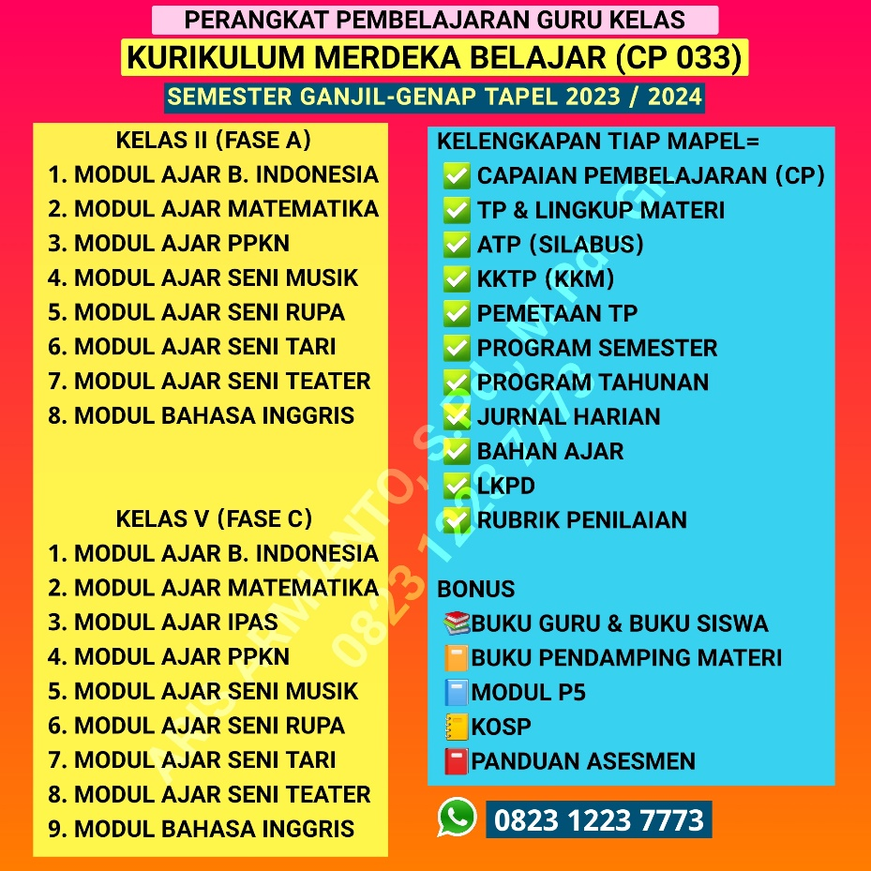

|  |  |  |
| --- | --- | --- |
| **PEMETAAN TUJUAN PEMBELAJARAN** | | |
| **Satuan Pendidikan** | **:** | **SD Negeri Unggulan 1** |
| **Kelas / Semester** | **:** | **V (Lima) / I (Ganjil)** |
| **Tahun Pelajaran** | **:** | **2023 / 2024** |

| **Mata Pelajaran** | | | **:** | **Seni Tari** | | | | |
| --- | --- | --- | --- | --- | --- | --- | --- | --- |
| Unit 1 | | | : | Keberagaman Unsur Pendukung Tari | | | | |
|  | | |  |  | | | | |
| **Pb** | **Tujuan Pembelajaran** | **Alur Tujuan Pembelajaran** | | | **Pertemuan ke-** | | | |
| **1** | **2** | **3** | **4** |
| **5** | **6** | **7** | **8** |
| 1 | Membedakan fungsi unsur pendukung tari yaitu, musik, properti, tata rias, dan tata busana bersumber dari tari tradisi melalui kegiatan pembelajaran inkuiri. | Mengalami  Peserta didik mampu mengindentifikasi unsur pendukung tari Jepin Selendang yaitu musik dan properti serta fungsinya dalam tari | | | √ |  |  |  |
| 2 | *Contoh Pemetan* | *Contoh Pemetan* | | |  |  |  |  |
| 3 | *Contoh Pemetan* | *Contoh Pemetan* | | |  |  |  |  |
| 4 | *Contoh Pemetan* | *Contoh Pemetan* | | |  |  |  |  |
| 5 | *Contoh Pemetan* | *Contoh Pemetan* | | |  |  |  |  |
| 6 | *Contoh Pemetan* | *Contoh Pemetan* | | |  |  |  |  |
| 7 | *Contoh Pemetan* | *Contoh Pemetan* | | |  |  |  |  |
| 8 | *Contoh Pemetan* | *Contoh Pemetan* | | |  |  |  |  |
| 9 | *Contoh Pemetan* | *Contoh Pemetan* | | |  |  |  |  |

|  |  |  |
| --- | --- | --- |
| **JURNAL HARIAN PELAKSANAAN PEMBELAJARAN** | | |
| **Satuan Pendidikan** | **:** | **SD Negeri Unggulan 1** |
| **Kelas / Semester** | **:** | **V (Lima) / I (Ganjil)** |
| **Tahun Pelajaran** | **:** | **2023 / 2024** |

| **Mata Pelajaran** | | | **:** | **Seni Tari** | | | |
| --- | --- | --- | --- | --- | --- | --- | --- |
| Unit 1 | | | : | Keberagaman Unsur Pendukung Tari | | | |
|  | | |  |  | | | |
| **Pb** | **Tujuan Pembelajaran** | **Alur Tujuan Pembelajaran** | | | **Materi** | **Penilaian** | **Tanggal** |
| 1 | Membedakan fungsi unsur pendukung tari yaitu, musik, properti, tata rias, dan tata busana bersumber dari tari tradisi melalui kegiatan pembelajaran inkuiri. | Mengalami  Peserta didik mampu mengindentifikasi unsur pendukung tari Jepin Selendang yaitu musik dan properti serta fungsinya dalam tari | | | Musik dan properti tari Jepin Selenda ng serta fungsinya | Sikap, pengeta huan, keterampilan |  |
| 2 | *Contoh Jurnal Harian* | *Contoh Jurnal Harian* | | |  |  |  |
| 3 | *Contoh Jurnal Harian* | *Contoh Jurnal Harian* | | |  |  |  |
| 4 | *Contoh Jurnal Harian* | *Contoh Jurnal Harian* | | |  |  |  |
| 5 | *Contoh Jurnal Harian* | *Contoh Jurnal Harian* | | |  |  |  |
| 6 | *Contoh Jurnal Harian* | *Contoh Jurnal Harian* | | |  |  |  |
| 7 | *Contoh Jurnal Harian* | *Contoh Jurnal Harian* | | |  |  |  |
| 8 | *Contoh Jurnal Harian* | *Contoh Jurnal Harian* | | |  |  |  |
| 9 | *Contoh Jurnal Harian* | *Contoh Jurnal Harian* | | |  |  |  |

|  |  |  |
| --- | --- | --- |
| **PROGRAM SEMESTER KURIKULUM MERDEKA BELAJAR** | | |
| **Satuan Pendidikan** | **:** | **SD Negeri Unggulan 1** |
| **Kelas / Semester** | **:** | **V (Lima) / I (Ganjil)** |
| **Tahun Pelajaran** | **:** | **2023 / 2024** |

| **Mata Pelajaran** | | | | | | | | **:** | | **Seni Tari** | | | | | | | | | | | | | | | | | | | | | | | | |
| --- | --- | --- | --- | --- | --- | --- | --- | --- | --- | --- | --- | --- | --- | --- | --- | --- | --- | --- | --- | --- | --- | --- | --- | --- | --- | --- | --- | --- | --- | --- | --- | --- | --- | --- |
| **Unit** | **Tujuan Pembelajaran** | **AW** | **Juli** | | | | | | **Agustus** | | | | | **September** | | | | | **Oktober** | | | | | **November** | | | | | **Desember** | | | | | **Keterangan**  **(Tanggal)** |
| **1** | **2** | **3** | **4** | **5** | | **1** | **2** | **3** | **4** | **5** | **1** | **2** | **3** | **4** | **5** | **1** | **2** | **3** | **4** | **5** | **1** | **2** | **3** | **4** | **5** | **1** | **2** | **3** | **4** | **5** |
| 1. Keberagaman Unsur Penduku ng Tari | 1. Membedakan fungsi unsur pendukung tari yaitu, musik, properti, tata rias, dan tata busana bersumber dari tari tradisi melalui kegiatan pembelajaran inkuiri. | 2 JP |  |  |  |  |  | |  |  |  |  |  |  |  |  |  |  |  |  |  |  |  |  |  |  |  |  |  |  |  |  |  | …. 2023 |
| 1. *Contoh Program Semester* |  |  |  |  |  |  | |  |  |  |  |  |  |  |  |  |  |  |  |  |  |  |  |  |  |  |  |  |  |  |  |  |  |
| 1. *Contoh Program Semester* |  |  |  |  |  |  | |  |  |  |  |  |  |  |  |  |  |  |  |  |  |  |  |  |  |  |  |  |  |  |  |  |  |
| 1. *Contoh Program Semester* |  |  |  |  |  |  | |  |  |  |  |  |  |  |  |  |  |  |  |  |  |  |  |  |  |  |  |  |  |  |  |  |  |
| 1. *Contoh Program Semester* |  |  |  |  |  |  | |  |  |  |  |  |  |  |  |  |  |  |  |  |  |  |  |  |  |  |  |  |  |  |  |  |  |
| 1. *Contoh Program Semester* |  |  |  |  |  |  | |  |  |  |  |  |  |  |  |  |  |  |  |  |  |  |  |  |  |  |  |  |  |  |  |  |  |
| 1. *Contoh Program Semester* |  |  |  |  |  |  | |  |  |  |  |  |  |  |  |  |  |  |  |  |  |  |  |  |  |  |  |  |  |  |  |  |  |
| 1. *Contoh Program Semester* |  |  |  |  |  |  | |  |  |  |  |  |  |  |  |  |  |  |  |  |  |  |  |  |  |  |  |  |  |  |  |  |  |
| 1. *Contoh Program Semester* |  |  |  |  |  |  | |  |  |  |  |  |  |  |  |  |  |  |  |  |  |  |  |  |  |  |  |  |  |  |  |  |  |
| **Asesmen Formatif** | 2 JP |  |  |  |  |  | |  |  |  |  |  |  |  |  |  |  |  |  |  |  |  |  |  |  |  |  |  |  |  |  |  |  |
| **Asesmen Sumatif** | 2 JP |  |  |  |  |  | |  |  |  |  |  |  |  |  |  |  |  |  |  |  |  |  |  |  |  |  |  |  |  |  |  |  |
|  | **Sumatif Tengah Semester** |  |  |  |  |  |  | |  |  |  |  |  |  |  |  |  |  |  |  |  |  |  |  |  |  |  |  |  |  |  |  |  |  |
|  | **Sumatif Akhir Semester** |  |  |  |  |  |  | |  |  |  |  |  |  |  |  |  |  |  |  |  |  |  |  |  |  |  |  |  |  |  |  |  |  |
|  | **Penyerahan Raport** |  |  |  |  |  |  | |  |  |  |  |  |  |  |  |  |  |  |  |  |  |  |  |  |  |  |  |  |  |  |  |  |  |